Legacy Delivery Application

# Stewart Hyde

### Introduction

This is old style MFC C++ application which I created to demonstrate the techniques of modernizing the old application with newer services and better support. In the real world this application could made of multiple screens and DLL’s written by different developers and with each having it own logging and possible own DLL. Before modernizing the old application, it best to combine the DLL’s into fewer DLL’s which make it easier to common logic. It may take the time to modernize the entire old application so part of the design goals of this project is to make the old Legacy application written in Microsoft Visual Studio 2008 compatible with a modern Microsoft .Net Core 3.1 application using Visual Studio 2019. Also, when a large old application is out in field, it can be difficult to track down errors and especially exception in code. A call stack is provided but requires debug code and PDB’s

This sample application was created from scratch and does not have existing database logic. But the idea of this project is demonstrating the process of make an old application still compatible with a newer generation application and communicates with data. This application was not designed to be on the internet and does and does not have the appearance and flexibility of web applications.

The following modernization techniques are demonstrated in this application

* Logging via .Net 3.5 Bridge.dll which supports log4net logging in C++ code. I was hoping to replace log4net with newer .Net Core Logging which has more abilities but initial findings, I found that it was too slow using a technique simpler to GetServiceXML method. I believe an ideal method for larger application would be memory transfer to a service which can handle the logging in more efficient manner. If done right – this could even include information that would allow structure logging so problems can be track down better.
* Enhance call stack logging available for exception and developer demand
* Ability to call .Net Core 3.1 service request from C++ via the .Net 3.5 Bridge.dll and .Net Core 3.1 GetServiceXML.exe
* Ability to router data to server via a .Net Core 3.1 Router via simple XML. This is use for both orders and messages.

### Compile considerations

To compile VS 2008 Code, you will need Microsoft Visual Studio 2008. To run the code, you need registered the bridge.dll with regasm.dll. If there is a desired to change exposed interface for bridge.dll or make a similar on using COM exposed interface. You need to run tlbexp on the dill to create TLB file.

The .Net core executables are contain within the netcoreapp3.1 directory in bin directory

### Example screens

The following is Legacy application main screen.

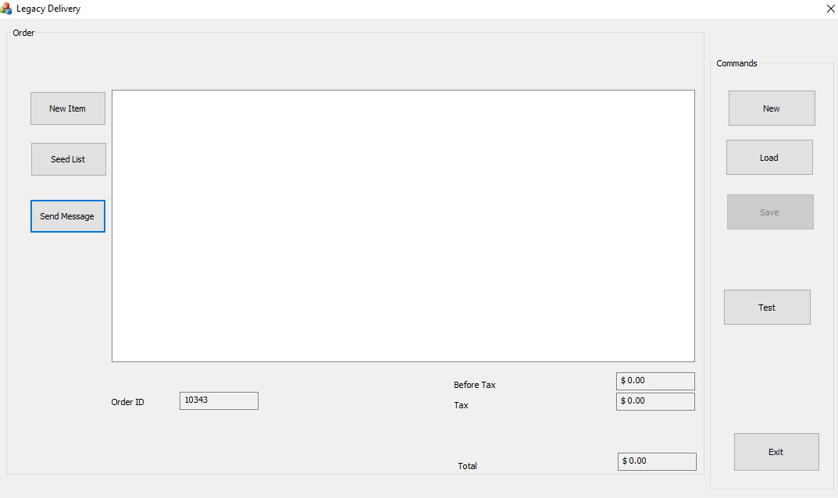

This is screen popup to send message

The following is example of xml generated when sending message

This is the screen to add customer information when new order or new item

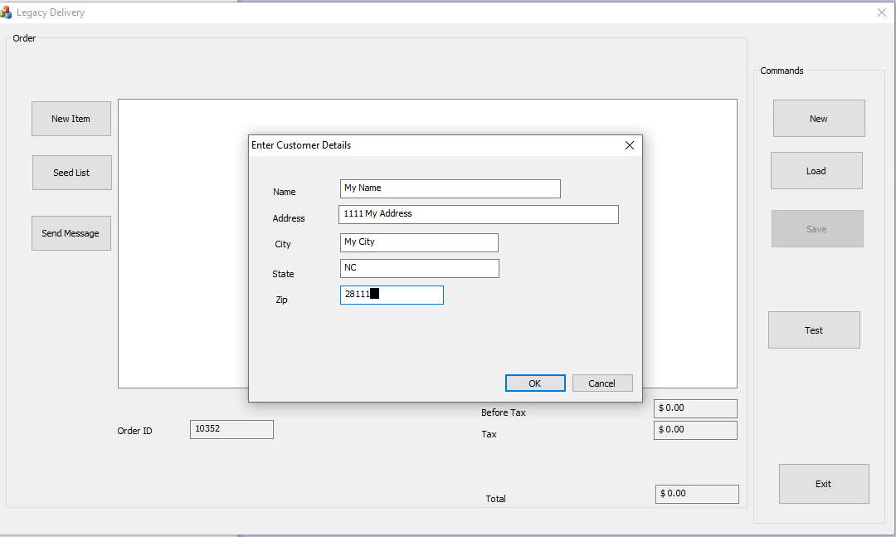

This is screen for adding a new item to order, item list is retried via GetServiceXML and retrieved from database via SQLServer

This is screen after adding some items to order

The following screen for saving the order – only real option now is for the router since logic for C++ to get XML is currently not added because I am trying to focus on using new technology and dealing with older technology takes time.

The following is example of the XML that C++ application will place in the Router’s directory to send to server

There is a so screen to test exception stack and call stack logging. Exception is done by divide by zero test and option to manually do a call stack.

